**An Analysis of Trends in the Canadian Housing Market**

Ronald Garcia, Anton Katipunan, Emily McClellan, Vida Rahmani, and Jagjeet Rathore

**(Group 7)**

Data Science 1: Foundations of Data Science

August 10, 2020

Table of Contents

Introduction 1

1 Objectives 1

1.1 Demographic Trends 1

1.2 Home Ownership 1

1.3 Financial Impacts 2

2 Data Sources 2

3 Challenges 3

4 Analysis 3

5 Demographic Trends 3

5.1 Population 3

5.2 Immigration 4

5.3 Household Income 5

5.4 Family Composition 6

6 Home Ownership 7

6.1 House Prices 7

6.2 Rental Market 9

6.3 First-Time Home Buyers 9

7 Financial Impacts 12

7.1 Mortgage Trends over Time 12

7.2 Mortgage Trends of Different Age Groups 12

Conclusions 13

References 14

**An Analysis of Trends in the Canadian Housing Market**

# Introduction

The housing market is often covered by mainstream media with respect to housing prices and the health of the industry. Trends in the housing market are analyzed closely because they are viewed as indicators for consumer confidence and, subsequently, the health of the economy. Unfortunately, this media coverage can be subject to bias if the source used to identify trends is an industry stakeholder, such as a real estate agent or mortgage broker. These parties may be using their opportunities in the media to instill confidence or spur fears to prompt business. For instance, an article on CBC.ca dated August 6, 2019 [1] cites the Toronto Real Estate Board (“TREB”) CEO stating that “there's a growing demand for residential properties due to population growth,” yet fails to reference actual trends in population growth that could be driving demand. TREB is a non-profit organization comprised of realtors who collect fees from real estate transaction. After reading a statement such as that made by the TREB CEO, potential home owners may be compelled to accelerate their pursuit of a new home.This report seeks to characterize the current state of the Canadian housing market by exploring demographic trends that impact demand, how such trends have influenced home ownership and, lastly, how the financial circumstances of Canadians have been affected.

# Objectives

## Demographic Trends

Canadian demographics continue to evolve and immigration is perennial driver of change. How has immigration affected population growth in major markets, and how have house prices changed in those markets? In these ever-growing cities, how does household income compare to housing prices (i.e. affordability)? Have families themselves changed in these cities (e.g. are couples having less children)?

## Home Ownership

As housing prices increase, potential home owners may be seeking alternatives. How has the rental market changed over time? How are first-time home buyers characterized?

## Financial Impacts

Given the rising costs of homes, it stands to reason that mortgages have followed suit since income levels have not grown at the same pace. How have mortgages changed over time?

# Data Sources

Statistics Canada (“Statcan”) is the primary source for the datasets used in this analysis. Statcan provides data on Population, Immigration, Family Composition, Housing Prices, Vacancy Rates, etc. The Canadian Mortgage and Housing Corporation (“CMHC”) provides a dataset for Median Household Income. To capture trends, this analysis uses datasets that span at least ten years where possible.

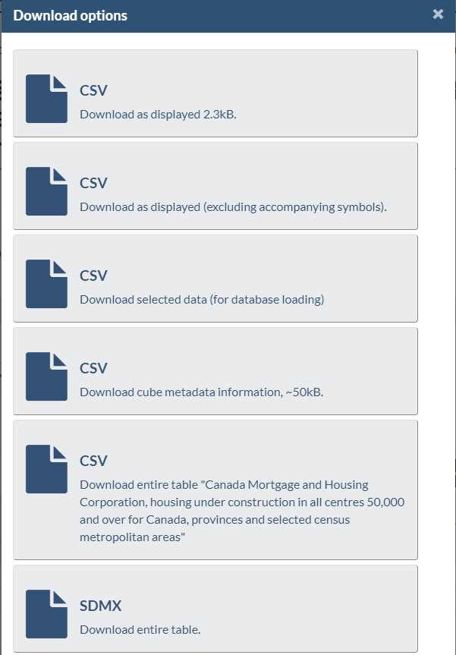

Figure 1 - Statcan Download Options

The data was collected by searching the Statcan website for housing topics. Once a dataset was found, it was filtered for the desired time period and necessary fields. Fortunately, Statcan provides a number of download options for its data. The data was downloaded using the third option (for database loading). In terms of structure, the data quality was very good.

The following datasets are utilized in this analysis:

1. Population estimates, July 1, by census metropolitan area, 2009-2019
2. Components of population change by census metropolitan area, 2016
3. Real Median After-Tax Household Income, 2006-2017 (2017 Constant Dollars)
4. Census families by age of older partner or parent and number of children, 2007-2017
5. Residential property price index, quarterly, Q1 2017-Q1 2020
6. Canada Mortgage and Housing Corporation, average rents for areas with a population of 10,000 and over, 2009-2019
7. Housing indicators, by tenure including first-time homebuyer status, 2018
8. Survey of Financial Security (SFS), assets and debts held by economic family type, by age group, Canada, provinces and selected census metropolitan areas, 1999-2016

# Challenges

The main challenge in searching for appropriate datasets is finding data that capture the same time period. Statcan did not collect data for certain aspects of the housing market until recently, such as first-time home buyer demographics. As one would expect, historical population and income data is readily available. However, another challenge is encountered as the frequency at which this data is collected differs from other datasets (i.e. every four years versus annually).

# Analysis

The Canadian marketplace can be examined through the lens of its six major consumer markets: Vancouver; Edmonton; Calgary; Toronto; Ottawa; and, Montreal. These cities capture a significant portion of Canada’s population. However, the scope of our analysis will capture three of these cities for simplicity and ease of identifying recognizable trends. As such, this report focuses on Toronto, Vancouver and Calgary. Toronto is the most populous metropolitan city in Canada and the trends occurring at a municipal level contribute greatly at a national level. Vancouver, while only third in terms of population size, is the most expensive housing market in Canada. In fact, according to CBRE’s Global Living 2019 report [2], Vancouver is the fourth most expensive housing market in world behind Hong Kong, Singapore and Shanghai (Toronto ranks 12th). Calgary was selected as a contrast to Toronto and Vancouver given that its economy, and consequently its housing market, are driven primarily by the oil and gas industry.

# Demographic Trends

## Population

Examining the Population Estimates data reveals that there is, in fact, population growth as the TREB CEO succinctly stated. However, the *rate of growth* has varied drastically between 2009 and 2019 for the VECTOM markets, as shown in Figure 2.

Once again, an uninformed reader of the aforementioned CBC.ca article might identify ‘population growth’ with a persistent upward trend in growth rate.

As Figure 2 shows, the growth rates for VECTOM markets has gradually progressed to stabilization since 2015, settling between 1.5% to 2.0%. Toronto has grown the fastest between 2015 and 2019. Calgary experienced rapid growth between 2011 and 2013 and a subsequent rapid decrease from 2013 to 2015, a response linked to the oil industry (Edmonton suffered the same fate). Vancouver’s growth rate has remained relatively stable, likely because the city has a more limited geography given its mountainous surroundings, and potentially due to its ever-increasing housing prices.

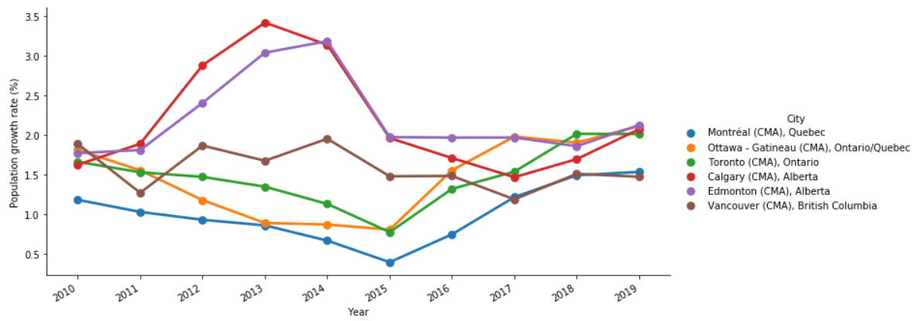

Figure 2 - Population Growth Rates, VECTOM

## Immigration

Immigration is cited as a major contributor to population growth, and is sometimes criticized as the primary reason for inflated housing prices. Between 2006 and 2019, Toronto has shown the highest levels of immigration amongst the major markets. Toronto experienced a decreasing rate of growth in total population between 2010 and 2015; it would appear that its main source of growth is immigration given that immigration levels in this time period were also decreasing. The subsequent rise in total population from 2015 to 2019 is once again matched by a similar pattern in immigration. Vancouver’s immigration pattern appears cyclical, while Calgary’s gradually increased until 2015 when it reached a peak, and began a gradual decline.

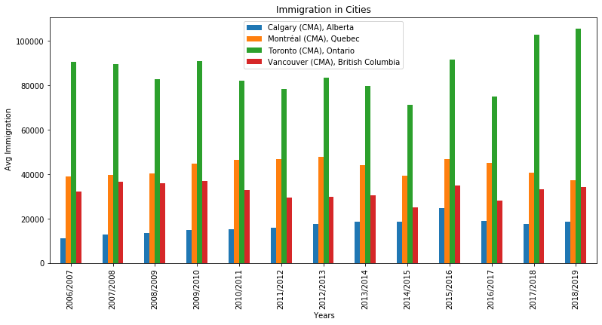

Figure 3 – Average immigration from 2006 to 2019

## Household Income

Analyzing the trends in the graph seen in household income are as follows. Calgary has the highest median of household income of all three cities by a significant amount, with a peak in 2013 and then a drop in 2013 and the leveling off again in 2017. Toronto has a slightly higher median household income than Vancouver with a peak back in 2010 and then a drop going from 2010 to 2012 and then a gradual rise of income with another peak at 2017. Vancouver has the lowest median household income with a drop in 2010 as well and then a gradual rise of income going up to 2017. In 2016, the median household income in Vancouver surpassed that of Toronto but the Toronto had a rise in 2017, making it once again higher than that of Vancouvers. These trends show tha the median household income in the past 10 years has overall been increasing which allows for homebuyers to increase the mortgate rate or 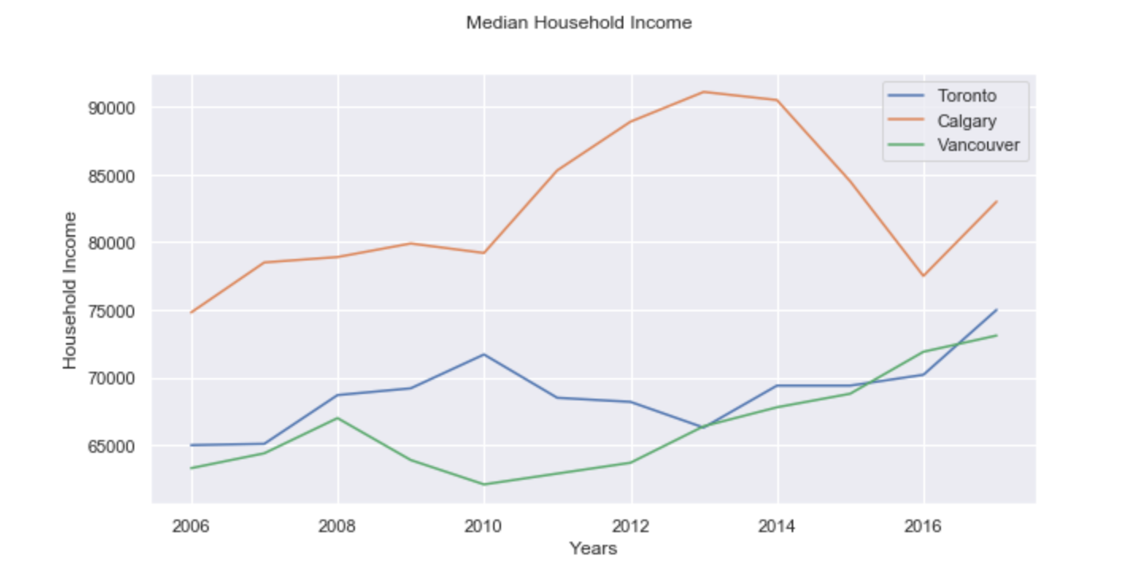rental rate of their choosing. This also means that if income is rising, the market prices would also rise.

Figure 4 – Median household income from 2006 to 2017.

## Family Composition

The worsening conditions for housing affordability may be impacting families’ decisions to have children. Reviewing the family composition over time can yield some insight.

Families with no children show the highest rate of increase in numbers over the years, with a growth rate of 2.3%. The growth rate for families with 1, 2, and 3 or more children are in the range of 0.9% to 1.2%. The growth rate of families with no children has almost been twice as the growth rate of other family compositions from 2007 to 2017.

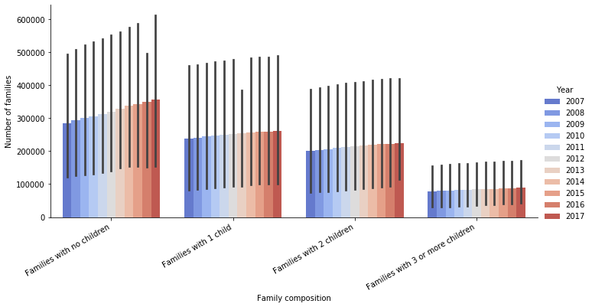

Figure 5 – Number of families of different family compositions

A closer inspection of the average family size shows that the overall impact of families deciding not to have children is insignificant.

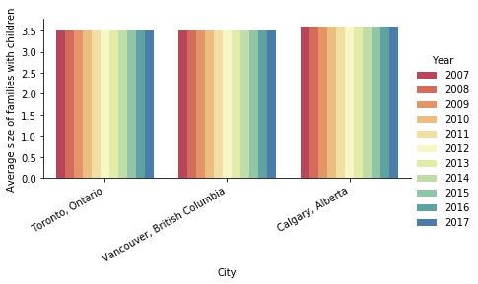

Figure 6 – Average size of families with children

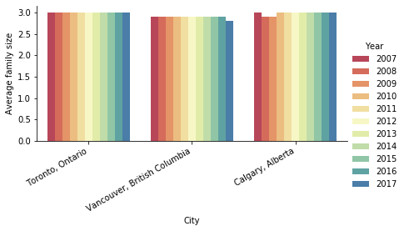

Figure 7 – average family size

# Home Ownership

## House Prices

In Toronto and Vancouver, there has been a persistent upward trend in Condominium prices since Q1 2017. Vancouver has reached a more stabilized level, while Toronto has not shown any evidence of stabilization. Meanwhile, Condominium prices in Calgary have been steadily decreasing in the same time period.

House prices peaked between 2017 and 2018 in Vancouver and Toronto and experienced a slight decline since then. However, they have gradually recovered and are close to 2017 levels once again. Calgary house prices decreased, unsurprisingly, however not at the same pace as condominium prices.

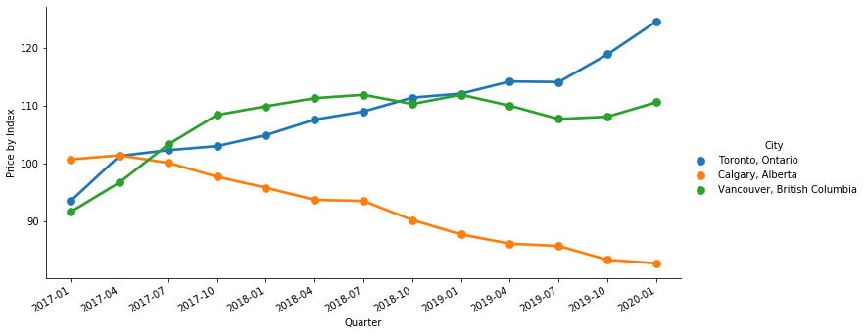

Figure 8 – Condominium prices since Q1 2017

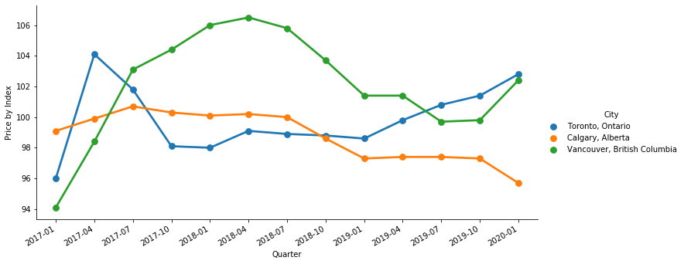

Figure 9 – house prices since q1 2017

## Rental Market

Vancouver and Toronto have shown steady declines in vacancy rates since 2009. This signifies a strong demand for housing. Calgary has experienced a completely opposite trend, with vacancy spiking in 2016 due to a lack of demand. Calgary actually had a lower vacancy rate than Vancouver and Toronto for a brief period between 2011 and 2014, but once again became victim to the swings of the oil industry. By 2019, Calgary's vacancy rate improved since its 2009 levels.

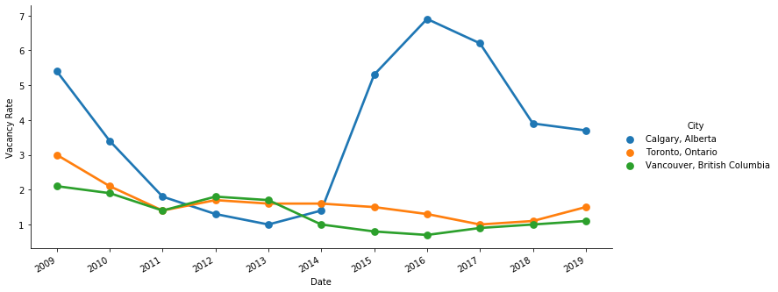

Figure 10 -vacancy rates from 2009 to 2019

## First-Time Home Buyers

The underlying trends in the housing market greatly influence the circumstances for first-time home buyers (“FTHB”). Comparing the FTHB profile with that of renters can provide insight into the current situation.

In Toronto, over 80% of renters live in an apartment while only 50% of FTHB purchased a condominium/apartment as their first home. One can conclude that most first-time home buyers in Toronto seek a larger dwelling. A similar trend is identified in the Calgary market, however a much greater majority of FTHB purchased a single-detached house. This is likely due to the lower prices of houses in Calgary versus Toronto. It is interesting to note that only 25% of FTHB in Calgary purchased a condominium versus 50% in Toronto. Vancouver exhibits a similar pattern as Toronto, with the difference being in the type of apartment building (more FTHB in Vancouver purchased in a low-rise building).

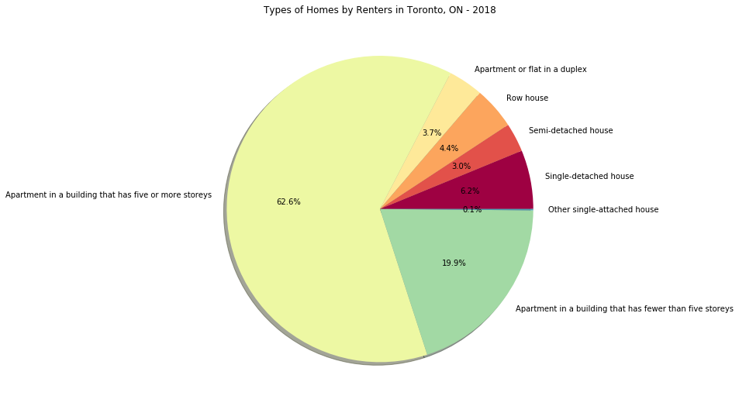

Figure 11 – types of homes by renters in toronto, on - 2018

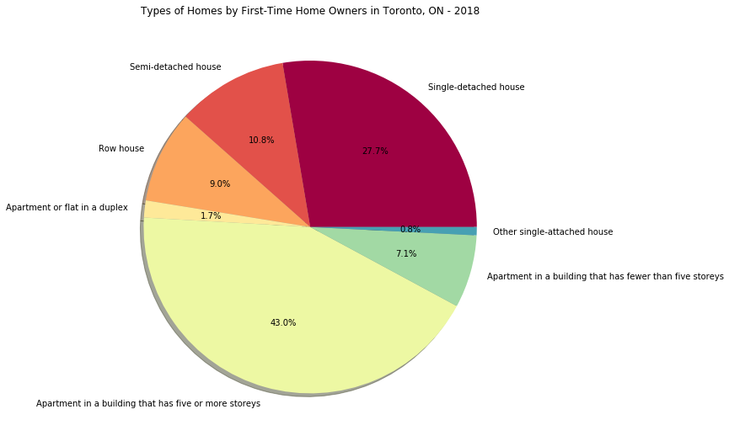

Figure 12 - types of homes by first-Time Home owners in toronto, on - 2018

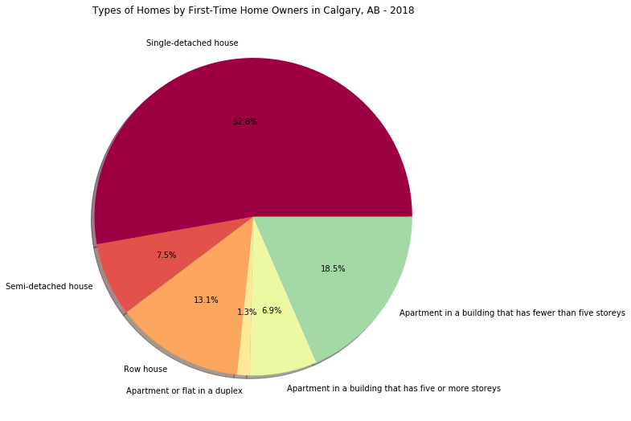

Figure 13 - types of homes by first-Time Home owners in Calgary, ab - 2018

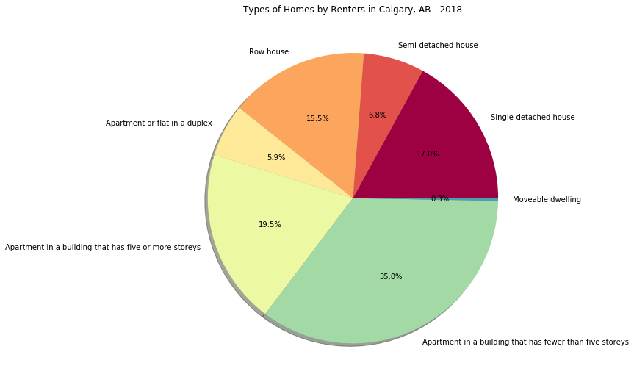

Figure 14 types of homes by renters in calgary, ab - 2018

# Financial Impacts

## Mortgage Trends over Time

The continued increase in house prices directly impacts mortgage values, as one would expect. Household incomes have simply not grown at the same rate as housing. In fact, mortgage values in 2016 are twice as average mortgage values in 1999.

Vancouver has the highest average of mortgage values, followed by Toronto, with Calgary showing the lowest amounts of average mortgage values throughout all years investigated here. Even though in 2012, the average mortgage values in Calgary slightly pass the average mortgage values of Toronto, they fall back to below the average values of both the other two cities in 2016. While the highest jumps in mortgage values among consequent data points of Toronto and Vancouver is 33% and 38% respectively, average mortgage values for Calgary have a 100% increase in value from 2005 to 2012, which is the highest rate of increase among consequent data points of all cities.

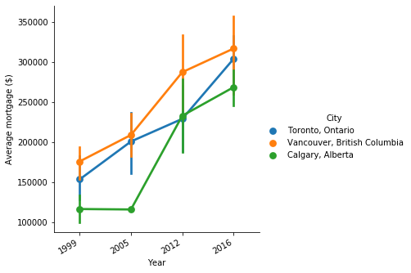

Figure 15 – Average mortgage values in Toronto, Vancouver, and calgary in different years

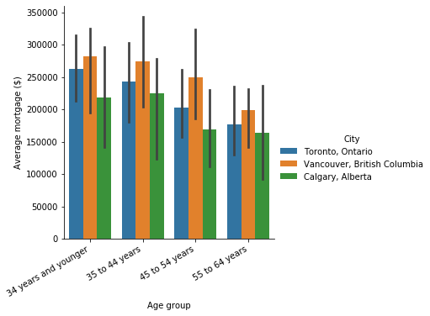

Figure 16 - Average mortgage values in Toronto, Vancouver, and calgary for different age groups

## Mortgage Trends of Different Age Groups

The average mortgage values for the two younger age groups (34 years and younger & 35-44 years) have slight differences in all cities (only 3% difference in Calgary and Vancouver, and 8% difference in Toronto). While Toronto shows consistent decrease in mortgage values as age is increased (8%, 16%, and 13% decreases between each of the two consequent age groups), Calgary and Vancouver show minimal mortgage differences (from 3% to 9%) between most age groups but also have one large mortgage gap between two age groups. Calgary has the its highest mortgage gap of 24% decrease between middle-aged groups (35-44 years & 45-54 years), for Vancouver, the significant difference of 20% is observed between the older-aged groups (45-54 years and 55-64 years)

# Conclusions

# References

[1] “Toronto area housing sales up 24.3% in July, prices rise due to tighter supply,” *The Canadian Press*, 2019. https://www.cbc.ca/news/canada/toronto/toronto-home-sales-1.5237143.

[2] CBRE, “Global Living Report 2019,” 2019. [Online]. Available: https://www.cbreresidential.com/uk/sites/uk-residential/files/property-info/FINAL REPORT.pdf.